**ASSIGNMENTS ON DIGITAL MARKETING**

**NAME:** K.SANTHINI

**DEPARTMENT:** ELECTRONICS AND COMMUNICATION ENGINEERING

**COLLEGE:**8151 DHANALAKSHMI SRINIVASAN INSTITUTE OF TECHNOLOGY

**NAANMUDHALVAN COURSE:** DIGITAL MARKETING

**NM ID:** F7BF4F5FE2EDCC6A41742FF80C72D7E4

**ASSIGNMENT 1:**

Create a blog or website using blogspot and WordPress .Customize the theme design and post new article with 500 words.

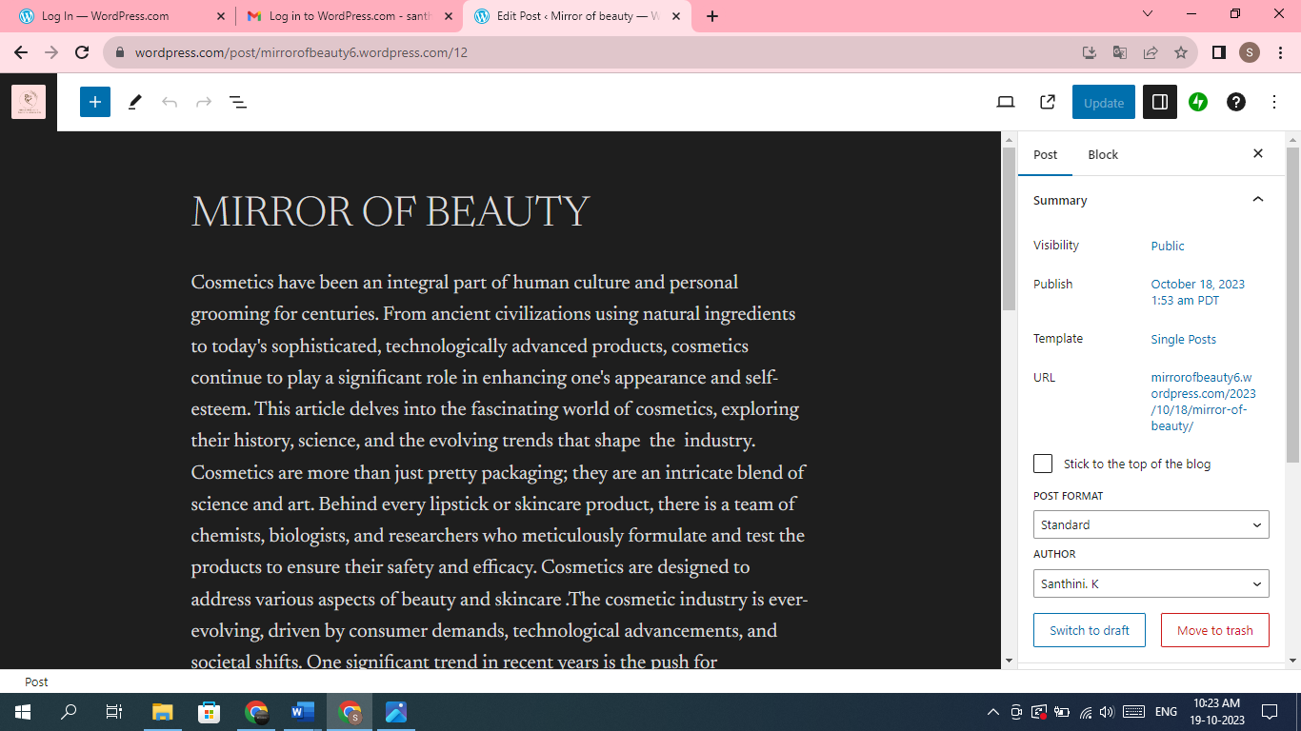

WORDPRESS LINK: <https://wordpress.com/post/mirrorofbeauty6.wordpress.com/12>

BLOGSPOT: <https://mirrorcu.blogspot.com/2023/08/welcome-to-mirror-of-beauty-where.html>

**ASSIGNMENT 2:**

create a new Facebook business page and post one social media poster for your

brand.

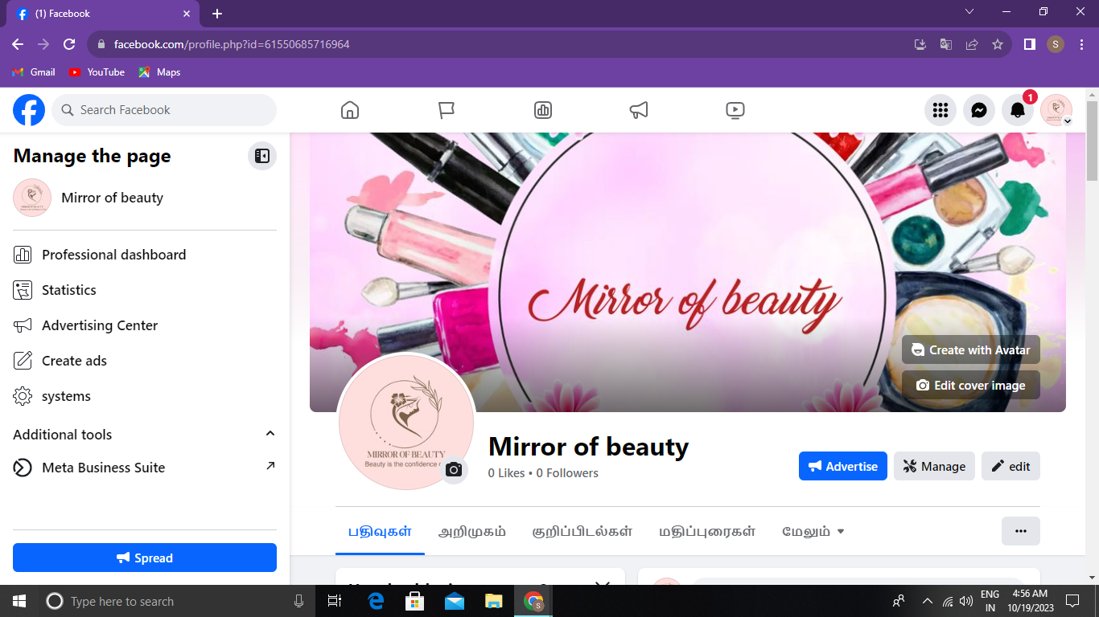

LINK: <https://www.facebook.com/profile.php?id=61550685716964>

**ASSIGNMENT 3:**

Create and design a social media advertisement poster using Canva.

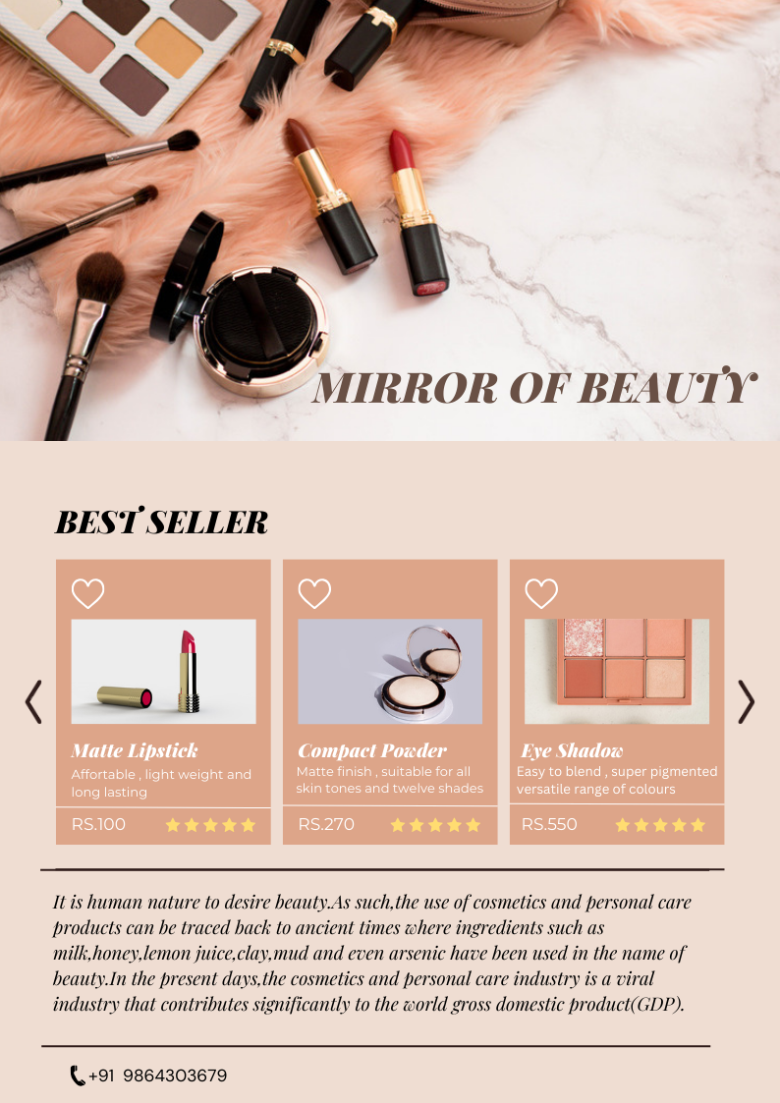

**ASSIGNMENT 4:**

Create email newsletter design using MailChimp or Canva tool.

